**Tentative Team/Game Name**:

Hell Chicago

**Jobs:**

Patrick → CSS/HTML Graphic Lead

Justin → Graphic/CS assistant

Cole → Twine Branching Creator

Luis → Twine Branching Creator

**Narrative Structure:**

3 ACT structure

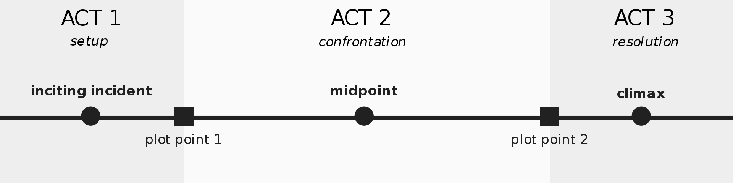

**Game Bible Phase**:

Sections of Game Bible:

**ADD YOUR INFORMATION TO THE GAME BIBLE DOCUMENT!!!**

Setting → Patrick

* Overall Scenario and world background, Map

Timeline → Cole

* How Long do all of these events take to transpire, a day, a week, a month?!! (That’s a long grubhub delivery)

Magic/Tech → Patrick

* What powers does Satan and other demons have?
* Are powers used to influence to story, if so how?
* How are hell and earth connected physically and why?

Culture/Language: → Justin

* How do the demons act? Is it the same as humans?
* What type of society is established here in Chicago? Talk to Patrick
* What types of jobs are there? Any major cultural differences?

Characters → Justin

Mechanics: Remembering information for checks and puzzle solving

* Culture of characters, design, backstory, drive, the environment they are in. For instance there are no coffee shops so how do the demons react when coffee is around for example. Talk to Patrick.

Plot → Cole

* The story is comedic, maybe not directly but can be. The characters find it normal and serious, but the player can find exaggeration funny. For example, the grubhub driver takes Satan’s job and is now ruler of hell. (Super outrageous)
* Creating the Branching Paths, overall story. Make sure you know what characters are needed so Justin can make them. Check with Patrick
* Can use the 7 deadly sins as endings. They don’t all have to necessarily kill the player but should be outrageous.